Backend Development with Node.js

Project Documentation

1. Introduction
Project Title: MicroGoal – Goal Tracking Application
Team ID:SWTID-202-8773
Team Size:4
Team Leader : SARANYA S – DEVELOPER
Mail id:saranyasi2007@gmail.com
Team member : RAMYA P – document creation
Mail id: ramyasaanthi@gmail.com
Team member : RISHIKA A – demo video
Email id: rishikabanu07@gmail.com
Team member : SAMYUKTHA A – coding
Mail id: samyukthaa34@gmail.com

The backend of the MicroGoal application is responsible for handling server-side operations, database management, authentication, and API services for the application.

2. Project Overview

Purpose
The purpose of the backend system is to manage user data and goals efficiently. It allows users to create, view, update, and delete goals securely through RESTful APIs.

Features
- User Registration
- User Login Authentication
- Create Goal
- Get All Goals
- Update Goal Status
- Delete Goal
- Secure API using JWT Authentication
- MongoDB database integration

3. Backend Architecture
The backend is built using a REST API architecture.

Technologies Used
- Node.js – Server-side runtime environment
- Express.js – Web framework for API development
- MongoDB Atlas – Cloud database
- Mongoose – MongoDB object modeling
- JWT (JSON Web Token) – Authentication
- bcryptjs – Password encryption
- dotenv – Environment variable management

4. Setup Instructions

Prerequisites
Before running the project, install the following software:
- Node.js
- npm (Node Package Manager)
- MongoDB Atlas Account
- Visual Studio Code

Installation Steps

Step 1: Clone or Open Project
Open the project folder in VS Code.

Step 2: Install Dependencies
Run the following command in terminal:
npm install

Step 3: Install Required Packages

npm install express mongoose cors dotenv jsonwebtoken bcryptjs

Step 4: Configure Environment Variables
Create a .env file
Example:
PORT=8000
MONGO_URI=your_mongodb_connection
JWT_SECRET=your_secret_key

Step 5: Run the Server
Start the backend server:
node index.js
Server will run on:
http://localhost:8000

5. Folder Structure
The backend project is organized as follows:
backend
│
├── models
│ userModel.js
│ goalModel.js
│
├── routes
│ userRoutes.js
│ goalRoutes.js
│
├── middlewares
│ authMiddleware.js
│
├── config
│ db.js
│
├── index.js
└── .env

Explanation
Models
Defines MongoDB database schemas.
Routes
Contains API endpoints for users and goals.
Middleware
Handles authentication and security.
Config
Manages database connection.

6. Running the Backend Application
To start the backend server, run:
node index.js
If the server starts successfully, the terminal will display:
Server running on port 8000
MongoDB connected

7. API Endpoints

User APIs

Register User
POST /api/users/register
Request Body:
{
"name": "Saranya",
"email": "saranya@gmail.com",
"password": "123456"
}

Login User
POST /api/users/login
Request Body:
{
"email": "saranya@gmail.com",
"password": "123456"
}
Response returns a JWT Token.

8. Goal APIs

Create Goal
POST /api/goals/create
Body:
{
"title": "Learn React"
}

Get All Goals
GET /api/goals
Returns all goals of the logged-in user.

Update Goal
PUT /api/goals/:id
Body:
{
"completed": true
}

Delete Goal
DELETE /api/goals/:id
Deletes the selected goal.

9. Authentication
The backend uses JWT Authentication.

Process
- User logs in with email and password.
- Server generates a JWT token.
- The token must be sent in request headers.
Example:
Authorization: Bearer TOKEN
- The authMiddleware verifies the token before allowing access to protected routes.

10.SCREENSHOTS

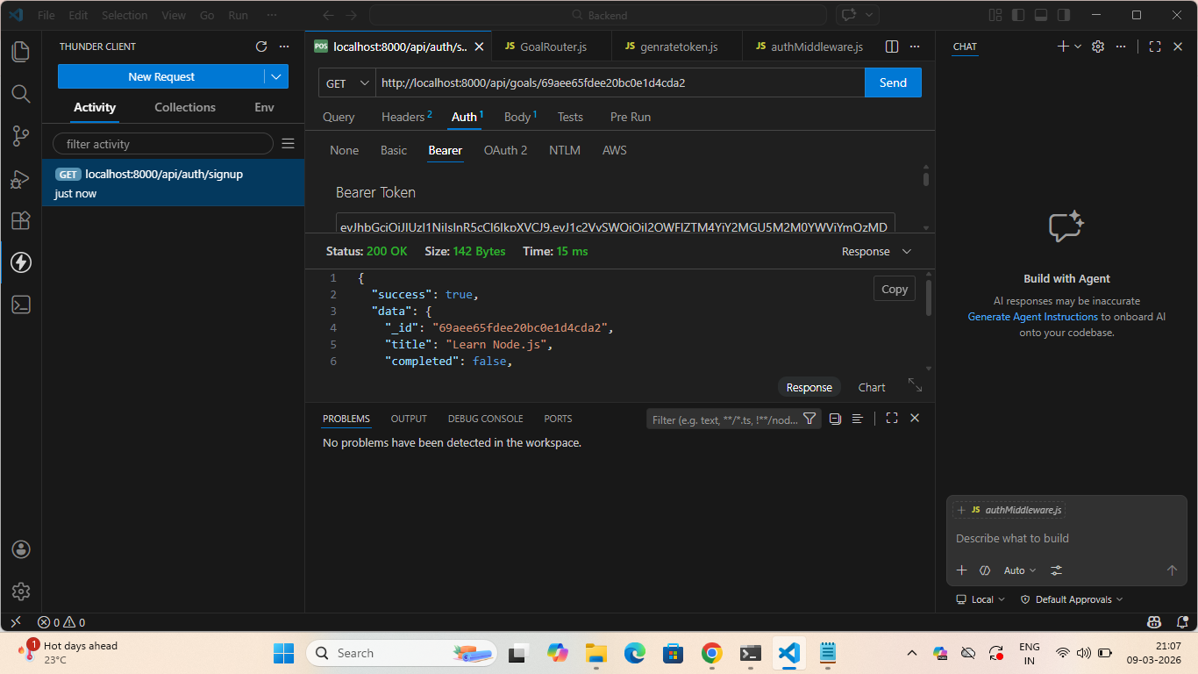
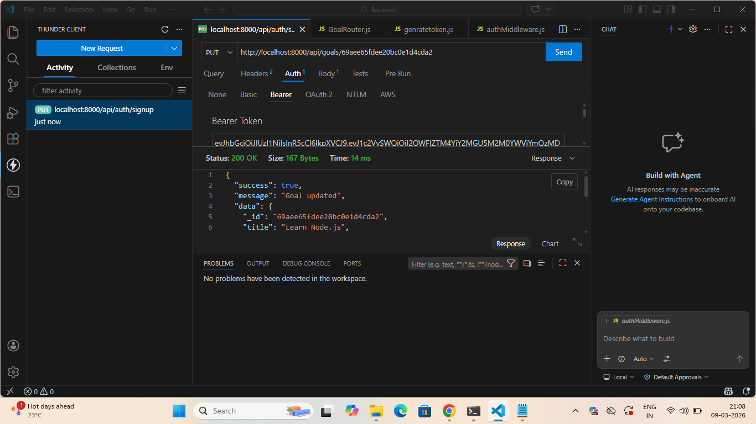
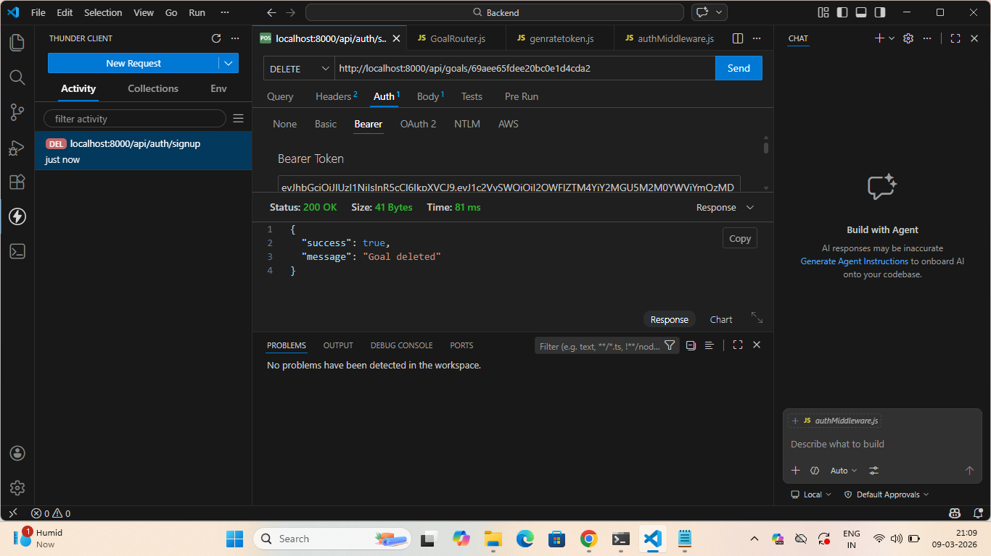

11. Database Design
The backend uses MongoDB Atlas for data storage.

User Collection
Fields:
- name
- email
- password

Goal Collection
Fields:
- title
- completed
- user (ObjectId reference)

12. Security Features
Security techniques implemented:
- Password hashing using bcryptjs
- JWT authentication
- Protected API routes
- Environment variable protection using dotenv

13. Testing
API testing is performed using Thunder Client / Postman.
Tested endpoints:
- User Registration
- User Login
- Create Goal
- Get All Goals
- Update Goal
- Delete Goal
All endpoints returned valid responses.

14. Known Issues
- Input validation can be improved
- Error handling can be enhanced

15. Future Enhancements
Possible future improvements:
- Goal deadline feature
- Goal progress tracking
- Email notifications
- Mobile application integration
- Advanced analytics dashboard

